* + What did you learn from the capture and/or from the videos? Which was your favorite video and why?

I learned how Wireshark logs and records all your web traffic from your computer the video about tcp traffic an streams was my favorite because it showed me how Wireshark can be used in the real world to monitor traffic

* + Place screenshots and description and submit in a single document encapsulating all of the above (one file either word, txt, or pdf)
  + Submit the file in Canvas under the Lab 2 assignment
  + Any issues with the above?

At your command prompt or terminal:

* Run ifconfig or ipconfig
  + what is your ip and netmask – is your IP routable? Why/why not?

10.1.124.28 is my internal Ip and 255.255.248.0 is my netmask my ip is routable due to the fact that it is an internal address and anyone on the same subnet would be able to connect to my pc

* + Which interface is your primary active interface?
* Ethernet 6 is my default interface due to my VM’s running on my pc use 1-5
* Run netstat –an
  + Do you have a connection on your pc to a foreign address? What is it? Who owns the IP? (may need to use ARIN.net or whois)

Yes I have many connections to foreran addresses stackoverflow:https its my web connection to stack overflow I have open in my browser and stack overflow owns the ip address

* 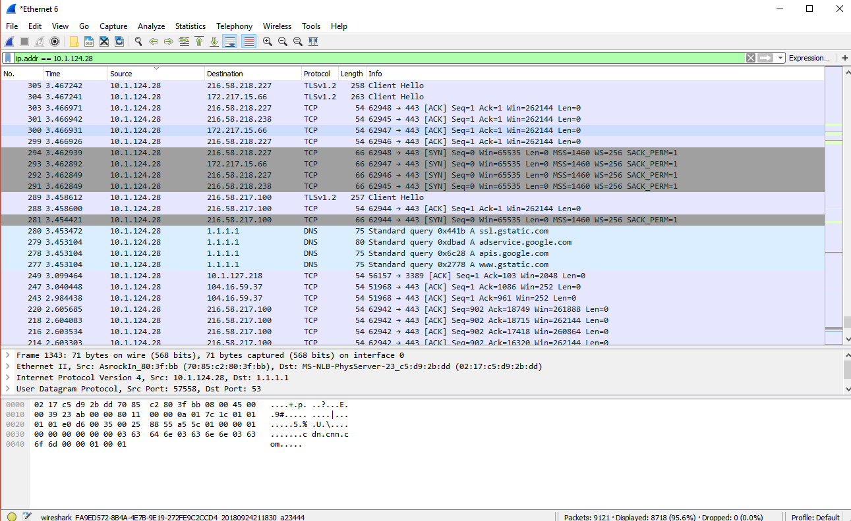Runwiresharkandcapturea (nslookup) lookup to [www.google.com (Links to an external site.)Links to an external site.](http://www.google.com/) & [www.cnn.com (Links to an external site.)Links to an external site.](http://www.cnn.com/) follow the DNS queries; then show the screen capture of theWireshark capture following those requests